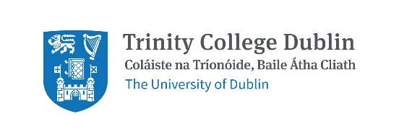
Trinity College Dublin
School of Natural Sciences
Department of Botany Transition Year Programme
April 2025

Application notes:
- Application deadline: January 31st 2025
- Please only submit an application if you can commit to the full programme.
- Please return your submission in MS Word format only by completing this document (please do not submit images, cloud-based documents etc.)

Please complete and return this application form via email to saundem@tcd.ie:

Please complete each section 1-3 below in full.

Section 1: Applicant Details:

Applicant Name
School Name
School address
Name of School TY coordinator

Section 2: Junior Certificate Results:

  - Please list all subjects studied and the grade awarded (please add extra rows to the table if required):

Subject | Grade Awarded

Section 3: Personal statement:

  - Please write a statement outlining your interest in this subject, your reasons for applying to the TCD Botany Department and the impact this course would have on your academic development (one-page maximum).

